Health Hub Medical Clinic Project Report

1.INTRODUCTION

1.1 Overview

I don't have access to real-time

information, and my knowledge is up to date only until September 2021. I'm not aware of a specific "Health Hub Medical Clinic" that may have been established after

that date. If you have specific questions or need information on a different topic, please feel free to ask, and I'll

do my best to help.

1.2 Purpose

"Health Hub Medical Clinic" is to provide medical

The purpose of a medical clinic like

services to patients. This typically includes diagnosis, treatment, and preventive care for various health conditions.

Such clinics may offer a range of services, including general medical care, specialized treatments, vaccinations,

wellness checks, and more, with the goal of promoting the health and well-being of the community they serve.

The specific services and mission of the clinic may vary, so it's advisable to check their website or contact them

for more details.

2.PROBLEM DEFINITION

&DESIGN THINKING

2.1 Empathy Map

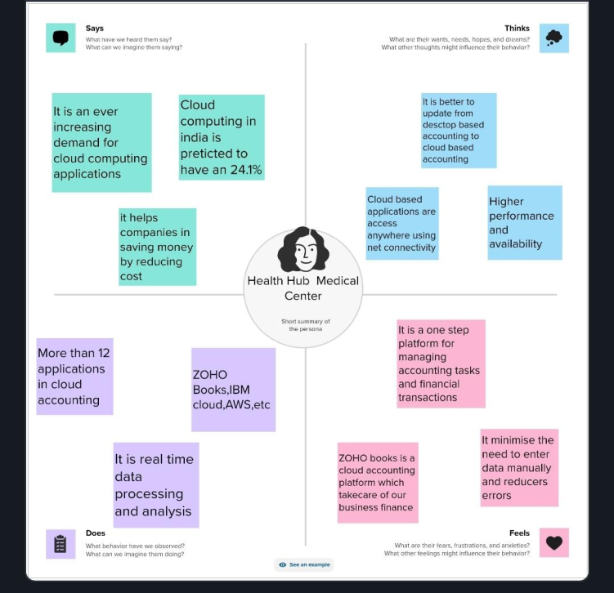

Creating an empathy map for a medical clinic like

"Health Hub" can help better understand

patients' needs and experiences. Here's a basic outline:

1. Say/Do: What do patients typically say and do when they visit the Health Hub clinic? Are they anxious, in

pain, or seeking information?

2. "Think/Feel": What might be going through their minds and hearts? Are they worried about their health,

Frustrated with long wait times, or seeking reassurance?

100% WORDS

ENGLISH

3. \*See: What do patients observe at the dinic? Is the waiting area clean and welcoming? Are staff

2.2 Ideation and Brainstorming Map

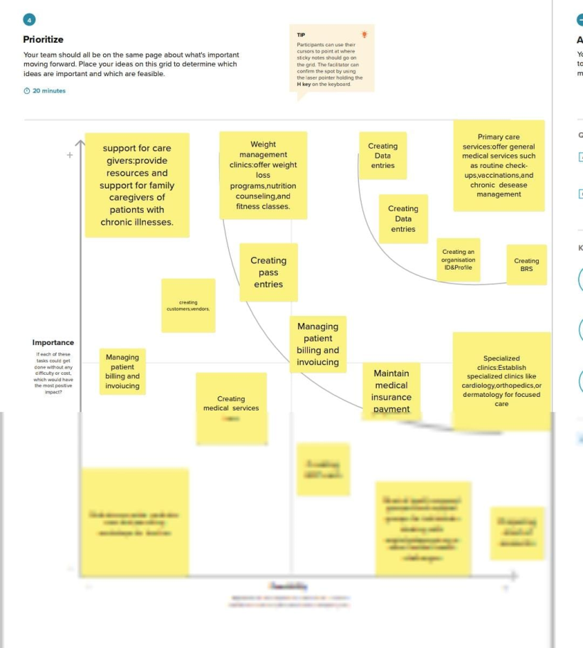

[12:40 PM, 10/17/2023]

BB: Creating a brainstorming map for a medical clinic

Clinic Name: Start at the center with "Health Hub Medical Clinic. "Services Offered: Branch out to list the medical services you plan to offer, such as general check-ups, specialized care, vaccinations, etc.Patient Experience:

Consider patient experience and map out ideas for a welcoming and comfortable clinic environment.Staffing:

Explore the types of medical professionals you need, like doctors, nurses, and administrative staff.Location:

Explore potential locations and accessibility Technology: Consider integrating technology like electronic health

records, telemedicine, or appointment scheduling...

[12:40 PM, 10/17/20231 BB: Creating a brainstorming map for a medical clinic called "Health Hub" can help

you generate ideas and plan effectively. Here's a basic structure to get you started:

1. "Clinic Name: Start at the center with "Health Hub Medical Clinic,"

2. Services Offered: Branch out to list the medical services you plan to offer, such as general check-ups,

specialized care, vaccinations, etc.

3. \*Patient Experience: Consider patient experience and map out ideas for a welcoming and comfortable clinic

environment.

4. \*Staffing: Explore the types of medical professionals you need, like doctors, nurses, and administrative staff.

5. Location: Explore potential locations and accessibility.

6. \*Technology: Consider integrating technology like electronic health records, telemedicine, or appointment scheduling apps.

7. \*Marketing: Brainstorm marketing strategies to attract patients and establish a strong online presence.

8. Community Involvement: Think about how the clinic can engage with the local community and provide

education or wellness programs.

9. Legal and Compliance: Ensure you have a branch to consider legal requirements and regulatory compliance.

10. \*Finances: Create a section for budgeting, funding, and potential revenue streams.

This brainstorming map will help you organize your thoughts and ideas for your Health Hub Medical Clinic.

You can use software tools or draw it on paper for a visual representation of your plan.

RESULT

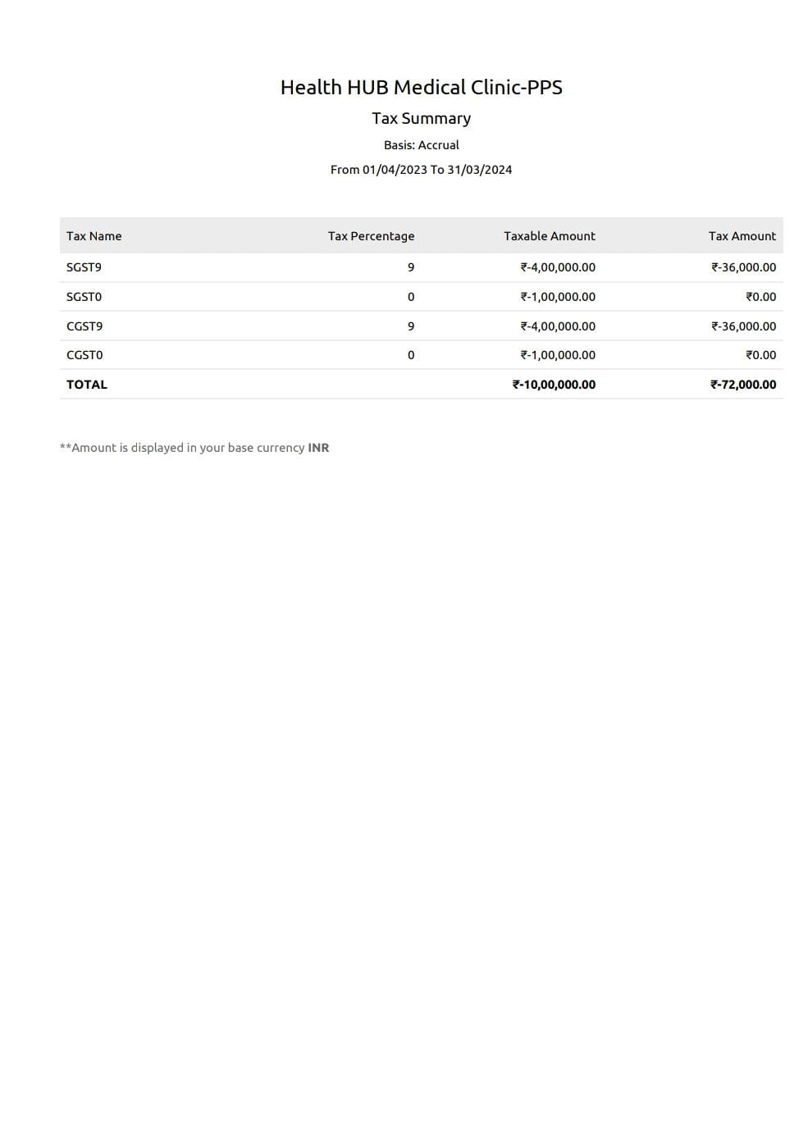

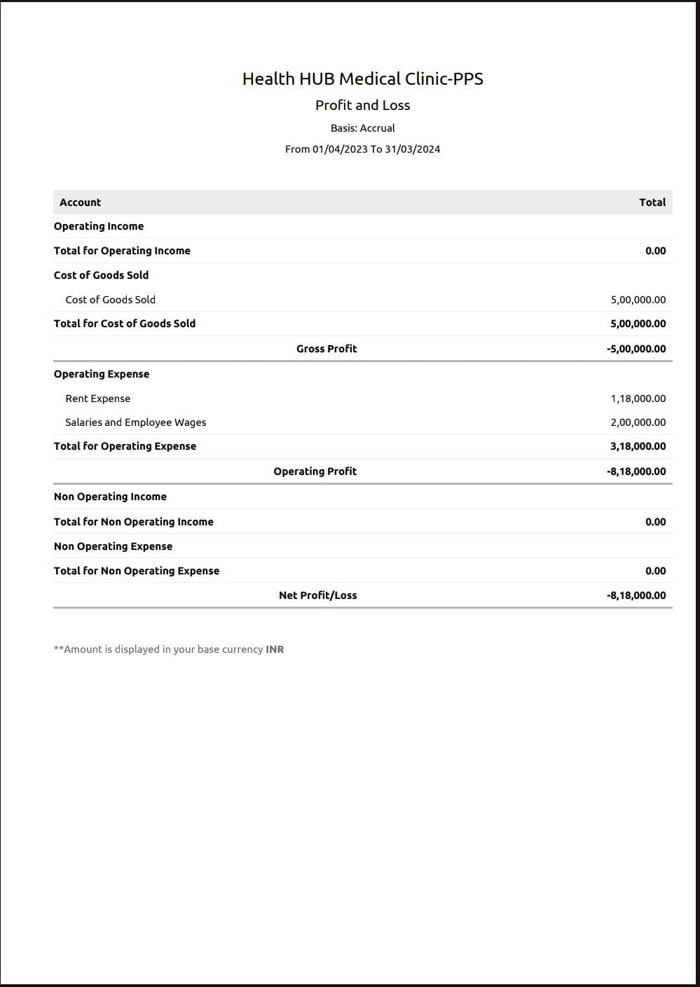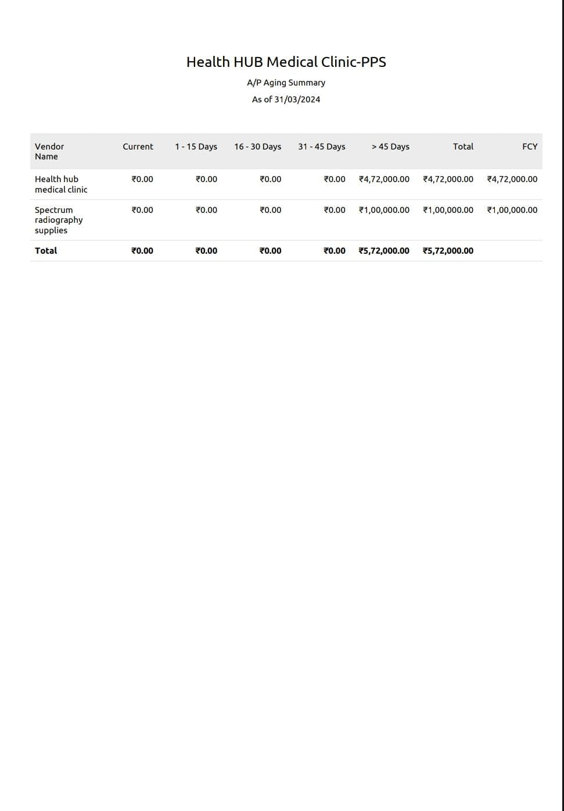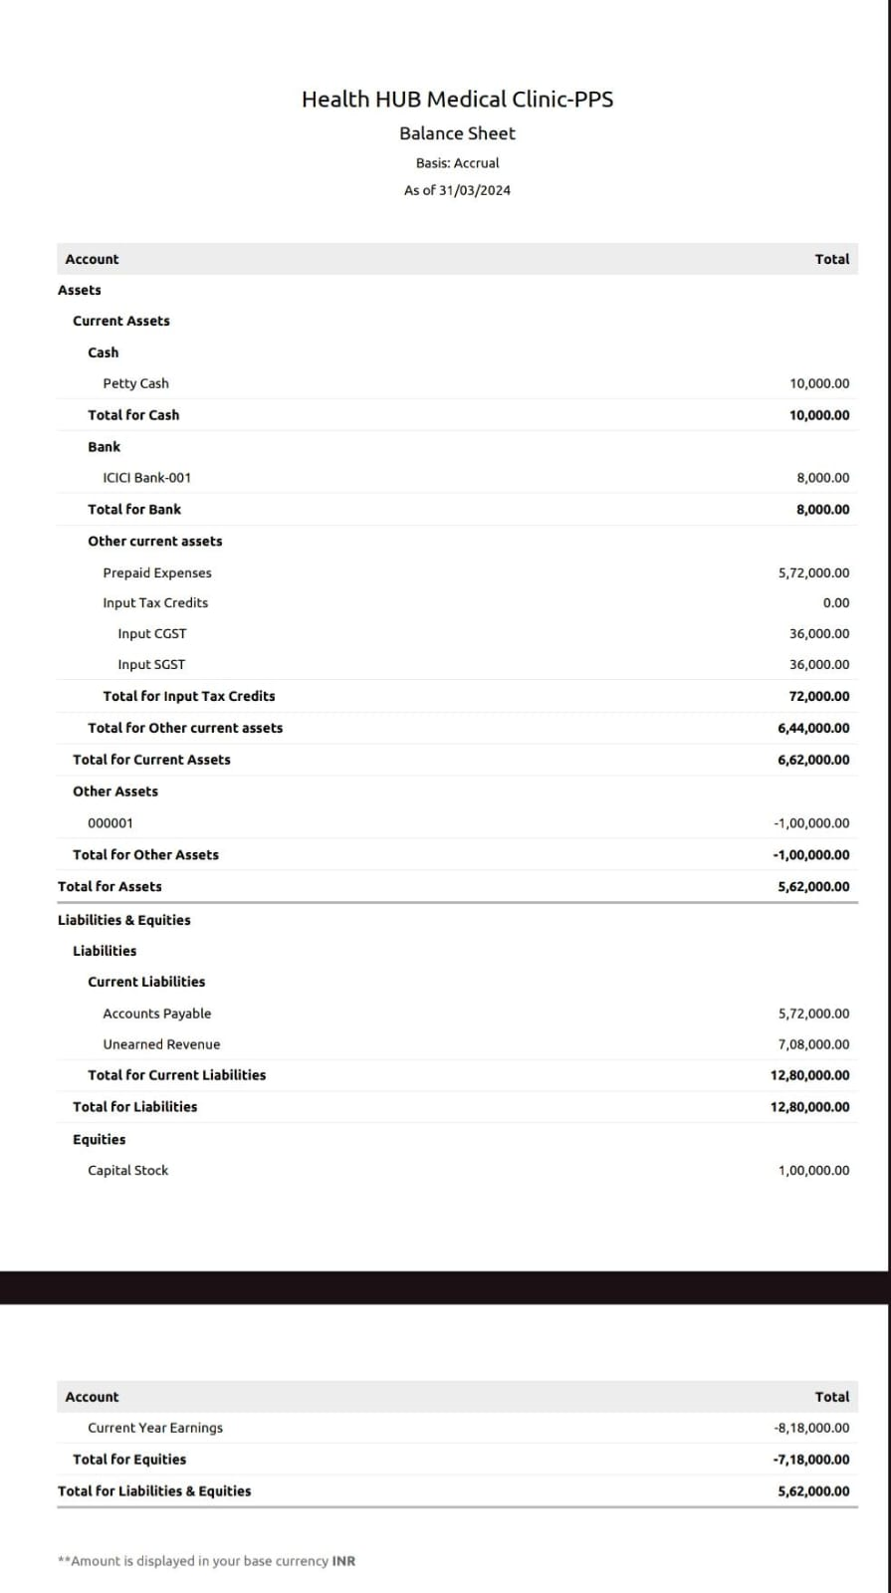

Health hub retrieves your lab test results from the medical record systems

of public health care

institusions .results are only available for general lab tests.

ADVANTAGES AND DISADVANTAGES

Advantages of a Health Hub Medical Clinic:

1. Comprehensive Care: Health hub clinics often offer a wide range of medical services under one roof, providing patients with convenient access to primary care, specialists, diagnostic tests, and other healthcare services.

2. Coordinated Care: Health hubs can facilitate better coordination of care among healthcare providers, leading to more integrated and patient-centered treatment plans.

3. Efficiency: Combining various medical services in one location can streamline the healthcare process, reducing the need for patients to visit multiple locations for their healthcare needs.

4. Convenience: Patients can often schedule appointments with multiple specialists in one visit, reducing the time and effort required for their healthcare.

5. Access to Technology: Health hub clinics may have advanced medical equipment and technology readily available, which can lead to faster and more accurate diagnoses and treatments.

Disadvantages of a Health Hub Medical Clinic:

1. Cost: Consolidated healthcare services may be costlier for patients, as there could be added facility fees or overhead costs associated with the convenience and comprehensive care.

2. Fragmented Care: In some cases, the diverse services offered by a health hub clinic may not be as coordinated as intended, leading to fragmented care and communication issues between different providers.

3. Limited Choice: Patients may be limited in their choice of healthcare providers, as health hub clinics specific doctors or specialists. high demand.

may have exclusive agreements with convenience of health hub clinics may lead to longer wait times for appointments, as they are often in

4. Long Wait Times: The

5. Overemphasis on Profit: Some critics

care, potentially leading to unnecessary

argue that health hub clinics may prioritize profits over patient tests or treatments.

The advantages and disadvantages can vary depending on the specific health hub clinic and the quality of care it provides. Patients should carefully evaluate their individual healthcare needs and preferences when choosing a healthcare provider.

APPLICATIONS

Health hub medical clinic applications could refer to software or platforms designed for medical clinics to manage various aspects of their operations, such as appointment scheduling, electronic health records (EHR), billing, and communication with patients. These applications are essential for streamlining administrative tasks and improving patient care. Some popular examples include Epic Systems, Cerner, and Allscripts for EHR, and solutions like Zocdoc or Doctolib for appointment booking. The specific application used may vary depending on the clinic's needs and preferences. If you have specific questions about medical clinic applications, feel free to ask.

CONCLUSION

I'm not sure what specific conclusion or information you're looking for about the "Health Hub Medical Clinic." Can you please provide more details or clarify your request?

FUTURE SCOPE

The future scope of a health hub medical clinic can be quite promising. Here are a few trends and opportunities to consider.

1. "Telemedicine Integration:\* The integration of telemedicine services will likely continue to grow, allowing patients to receive healthcare remotely. This can expand your reach and make healthcare more

accessible.

and Al: Embracing health technologies and Al can improve diagnostics, patient care, and administrative tasks. Al can help with data analysis, patient scheduling, and even predictive

2. "Health Tech

healthcare.

\* Focus on preventive healthcare and wellness programs. This can nutrition guidance, and fitness programs to keep patients healthy.

3. \*Preventive Care and Wellness:

include lifestyle counseling,

Chronic Disease Management:\* With an aging population, there will be an increased demand for managing chronic diseases. Specialized clinics for diabetes, heart disease, or other chronic conditions can be a niche to explore.

APPENDIX

A. SOURCE CODE

This is for informational purposes only. This information does not constitute medical advice or diagnosis.

The appendix is a 4-10 cm long, finger-like structure that's located in the right lower part of the abdomen. It's part of the large intestine and contains cells that help fight infection.